SUZUKI DEALER MANAGEMENT SYSTEM (SDMS) – TO BE & FDD

SEJAHTERA BUANA TRADA (SBT) & SUZUKI MOTOR GEMILANG (SMG)

Document Information
File Name | Document
SDMS (TO-BE) – SBT & SMG

Change Records
Date | Author | Version | Change Reference
Feb-2014 | Hasim | 1.0

Reviewer
Name | Position

Table of Contents

SEJAHTERA BUANA TRADA (SBT) & SUZUKI MOTOR GEMILANG (SMG) 1
1 OBJECTIVE / SCOPE 3
1.1 Objective 3
1.2 SCOPE 5
2 BUSINESS PROCESS FLOW 6
2.1 Business Flow 6
2.1.1 Sales Operation 6
2.1.1.1 Direct Sales 6
2.1.1.2 Sales Return 7
2.1.2 Spare Part Operation 8
2.1.2.1 Direct Sales 8
2.1.2.2 Spare part Return 9
2.1.3 Service Operation 10
2.1.3.1 Service 10
2.1.3.2 Warranty Claim 11
2.1.3.3 PDI & FSC 12
2.1.3.4 Service Return 13
2.2 Business Flow Description 14
2.3 How To Process 15
2.3.1 Service Operation 16
2.3.1.1 Input SPK 16
2.3.1.2 Generate Invoice (Faktur Penjualan & Faktur Penjualan Batch) 17
2.3.1.3 Cancel Invoice (Cancel Faktur Penjualan) 18
2.3.2 Spare Part Operation 19
2.3.2.1 Entry Pengeluaran Stock 19
2.3.2.2 Pembuatan PL & Entry Picked Qty PL 19
2.3.2.3 Pembuatan Lampiran Dokumen Non Penjualan 19
2.3.2.4 Pembuatan Lampiran Dokumen Service (combine 1 + 2 + 3) 19
2.3.2.5 Entry Retur Supply Slip 20
2.3.2.6 Entry Retur Service 21
2.3.2.7 Posting MD & SD (only for MD Database) 21
2.3.2.8 Posting MD & SD (only for SD Database) 24
3 APPROVAL 26

OBJECTIVE / SCOPE

Objective

Current condition:
- BIT, IJMG, SVMG, ISG and ISMG selling Units, Spare parts and Service to Sub-dealers, Part Shop and Customer.
- Each dealer have headquarters and many outlets

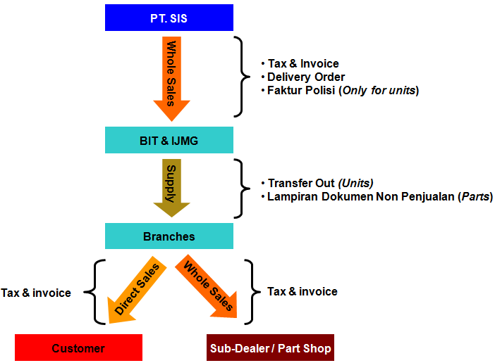

Future condition:
- BIT selling Units, Spare part and Service to Sub-dealers (include SBT dealer) and Part Shop
- IJMG, SVMG, ISG, ISMG selling Units, Spare part and Service to Sub-dealers (include SMG dealer) and Part Shop.
- SBT or SMG selling Units, Spare parts and Service to customer.
- BIT & IJMG only have headquarters.
- SBT and SMG have headquarters and many branches.
- All branches of BIT become SBT branches.
- All branches of IJMG, SVMG, ISG, ISMG become SMG branches.

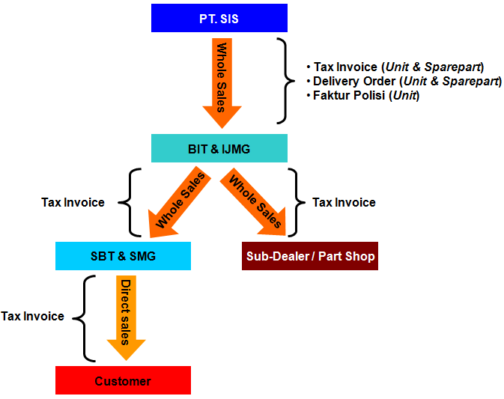

Constraint:
- Dealer SBT and Dealer SMG should not have stock.

SCOPE

SDMS need to enhance for support SBT dealer and SMG dealer.

- The new function will develop using WEB base.
- Special process including automatic process in
- Sales operation
- Spare part operation
- Service operation

BUSINESS PROCESS FLOW

Business Flow

Sales Operation

Direct Sales
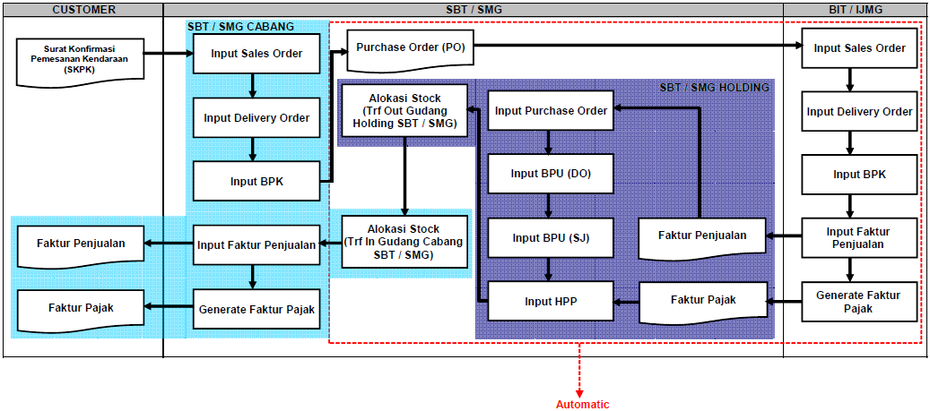

Sales Return
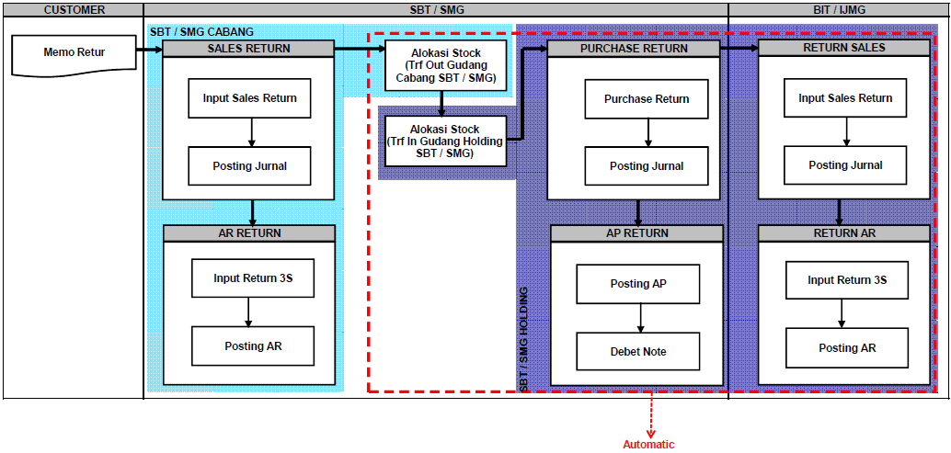

Spare Part Operation

Direct Sales
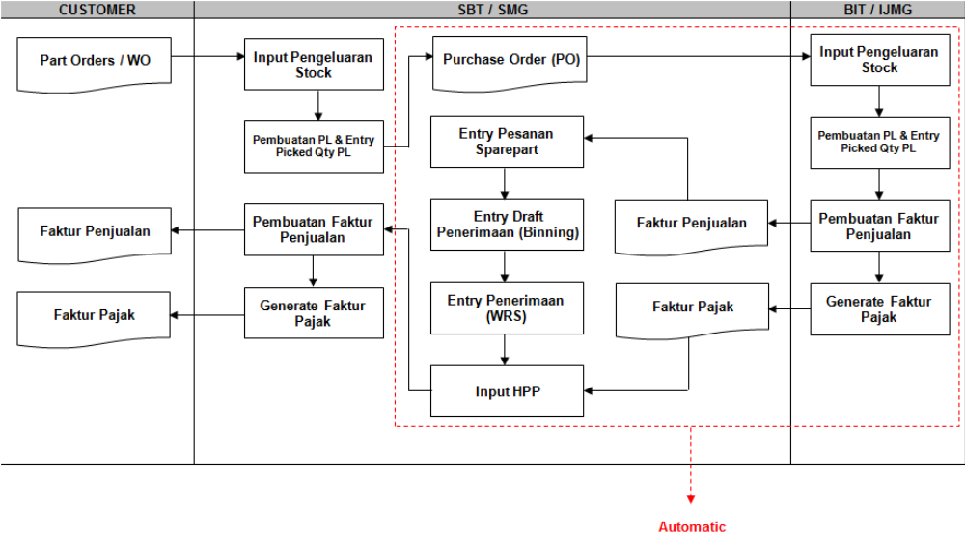

Spare part Return
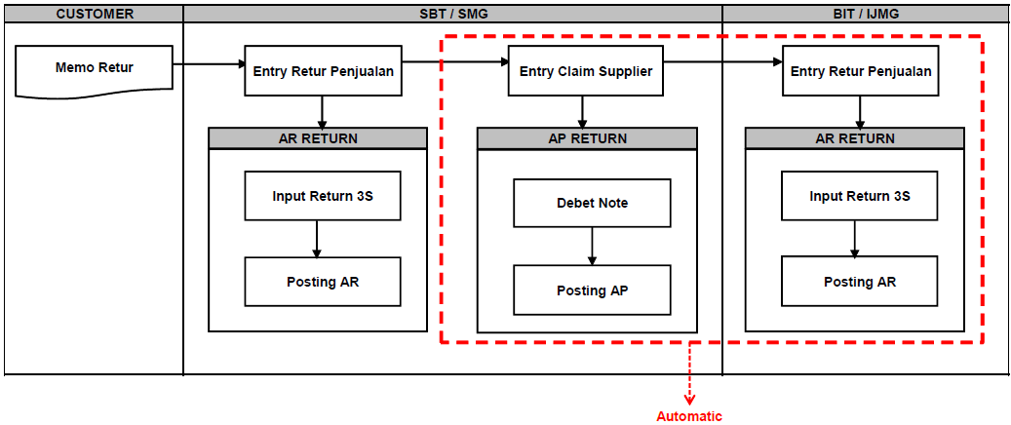

Service Operation

Service
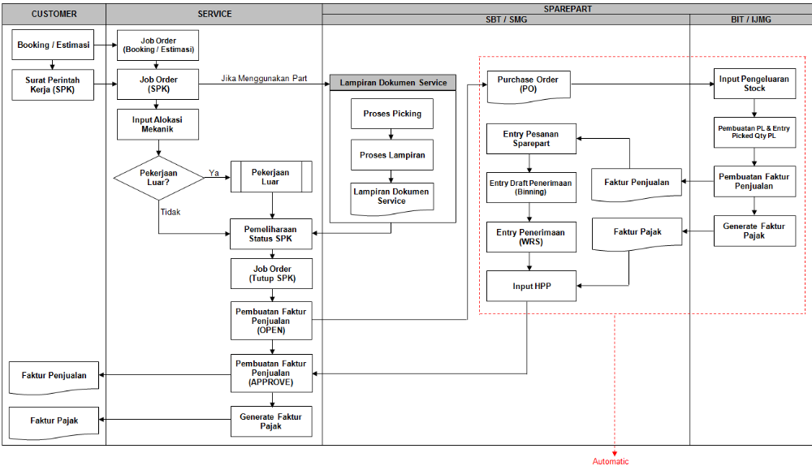

Warranty Claim
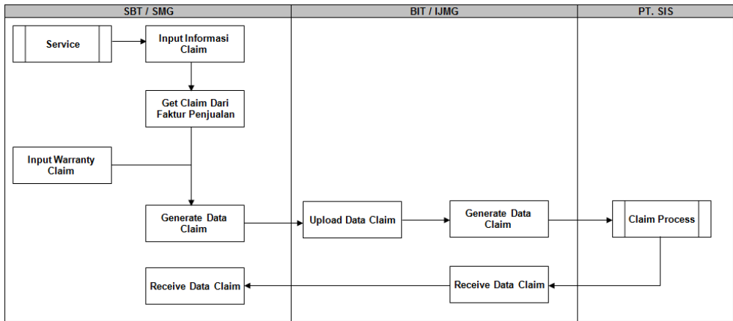

PDI & FSC
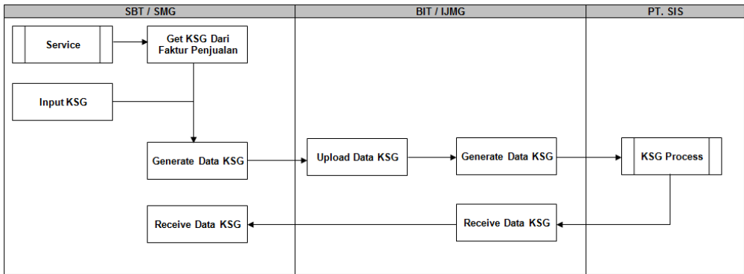

Service Return
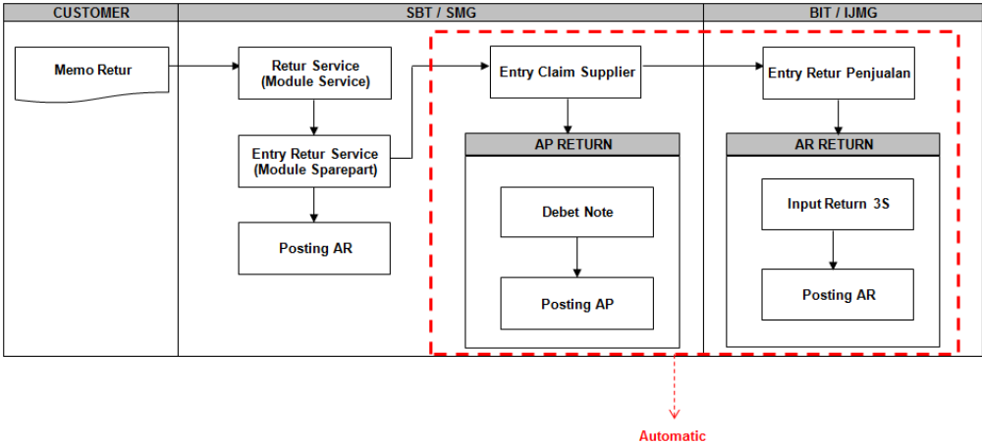

Business Flow Description

How To Process

Consider about :
- Check table of gnMstLookUp (Header & Detail)
- CodeID = ‘DELR’
- LookUpValue = SBT/SMG company code
- ParaValue = ‘1’
If ParaValue = ‘1’ used for dealer SBT/SMG
If ParaValue = ‘0’ or NULL used for all dealers (exclude SBT/SMG)

- Check table of gnMstLookUp (Header & Detail)
- CodeID = ‘DELR’
- LookUpValue = ‘MD’
- ParaValue = BIT/IJMG/SVMG/ISG/ISMG company code

- Check table of gnMstCompanyMapping
Field Name | Type | Description
CompanyCode | varchar(15) | Company Code (SBT/SMG Company Code)
BranchCode | varchar(15) | Branch Code (SBT/SMG Branch Code)
BranchName | varchar(100) | Branch Name (SBT/SMG Branch Name)
DbName | varchar(15) | Database Name (SBT/SMG Database Name)
MappingType | bit | ‘0’ : using Holding  ‘1’ : using Branch
CompanyMD | varchar(15) | Company MD Code
BranchMD | varchar(15) | Branch MD Code  ‘0’ : ex. ‘6006400’ ➔ mapping to holding  ‘1’ : ex. ‘6006406’ ➔ mapping to branch
BranchNameMD | varchar(100) | Branch MD Name
DbMD | varchar(15) | Database MD
WarehouseMD | varchar(15) | Warehouse MD Code  ‘0’ : ex. ‘10’ ➔ mapping to holding warehouse  ‘1’ : ex. ‘00’ ➔ mapping to branch warehouse
isStatus | bit | ‘0’ : active  ‘1’ : not active

Note:
- BIT / IJMG / SVMG / ISG / ISMG dealer ➔ database MD
- SBT / SMG dealer ➔ database SD

Service Operation

Input SPK
- Different process for Quantity Available & Cost Price for MD or SD
QtyAvail  (see the red box in the picture) | MD  atau  SD | QtyAvail = isnull (( select OnHand–AllocationSP–AllocationSR–AllocationSL  from MD.spMstItems  where CompanyCode= CompanyMD  and BranchCode=BranchMD  and PartNo=@PartNo ) ,0.0 )  atau  isnull (( select OnHand–AllocationSP–AllocationSR–AllocationSL  from MD.spMstItems  where CompanyCode= CompanyMD  and BranchCode= BranchMD  and PartNo=@PartNo  and WarehouseCode=WarehouseMD ) ,0.0 )
CostPrice | MD | MD.spMstItemPrice.CostPrice
CostPrice | SD | DiscPct(Purchase Discount)  = isnull (( select DiscPct from SD.gnMstSupplierProfitCenter  where CompanyCode=@CompanyCode  and BranchCode=@BranchCode  and SupplierCode=CompanyMD ), 0.0)  CostPrice = MD.spMstItemPrice.RetailPrice / 1.1 ( ( 100 – DiscPct ) / 100.0 )

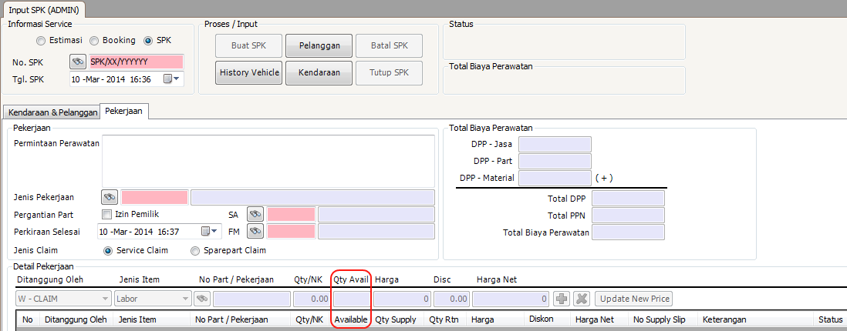

Insert/Update svSDMovement only used for SD & SPK which using Part/Material
Field Name | Type | Description
CompanyCode | varchar(15) | Company Code (SBT/SMG Company Code)
BranchCode | varchar(15) | Branch Code (SBT/SMG Branch Code)
DocNo | varchar(15) | Document Number (Job Order Number)
DocDate | datetime | Document Date (Job Order Date)
PartNo | varchar(20) | Part Number
PartSeq | integer | Sequence
WarehouseCode | varchar(15) | Warehouse Code
QtyOrder | numeric(18,2) | First Order Quantity (before correction)  Same as DemandQty from svTrnSrvItem
Qty | numeric(18,2) | Quantity
DiscPct | numeric(6,2) | Discount Percentage
CostPrice | numeric(18,2) | Cost Price = RetailPrice – (RetailPrice x DiscPct / 100)  Select DbMD.spMstItemPrice.RetailPrice  Select DbMD.gnMstCustomerProfitCenter.DiscPct  No decimal point for Cost Price result
RetailPrice | numeric(18,2) | Retail Price
TypeofGoods | varchar(5) | Type of Goods
CompanyMD | varchar(15) | Company MD Code (BIT/IJMG/SVMG/ISG/ISMG Code)
BranchMD | varchar(15) | Branch MD Code (BIT/IJMG/SVMG/ISG/ISMG Code)
WarehouseMD | varchar(15) | Warehouse MD Code
RetailPriceInclTaxMD | numeric(18,2) | RetailPriceInclTax from DbMD.spMstItemPrice
RetailPriceMD | numeric(18,2) | RetailPrice from DbMD.spMstItemPrice
CostPriceMD | numeric(18,2) | CostPrice from DbMD.spMstItemPrice
QtyFlag | char(1) | ‘x‘ - for SPK  Notes:  ‘+’ - Addition quantity  ‘-‘ - Subtract quantity  ‘x‘ - No transaction
ProductType | varchar(15) | ProductType
ProfitCenterCode | varchar(15) | Profit Center Code
Status | char(1) | ‘0’ - Open Job Order  ‘1’ - Dalam Pengerjaan / Progress Service  ‘2’ - Tes Drive / Test Drive  ‘3’ - Pemeriksaan Akhir / Final Check  ‘4’ - Pencucian / Washing  ‘5’ - Tutup SPK / Closed SPK  ‘6’ - Batal SPK / Cancel SPK  ‘7’ - Invoice / Invoice  ‘8’ - Batal Invoice / Cancel Invoice  ‘9’ - Faktur Pajak  ‘A’ - Batal Faktur Pajak / Cancel Faktur Pajak  ‘B’ - Retur Faktur Pajak / Faktur Pajak Return
ProcessStatus | char(1) | ‘0’ - New  ‘1’ - Posting
ProcessDate | Datetime | Process Date
CreatedBy | varchar(15) | Created By
CreatedDate | datetime | Created Date
LastUpdateBy | varchar(15) | Last Update By
LastUpdateDate | Datetime | Last Update Date

Generate Invoice (Faktur Penjualan & Faktur Penjualan Batch)
For SD, the process does not cut the stock on hand (OnHand)
Insert svSDMovement only used for SD & invoice using Part/Material
Field Name | Type | Description
CompanyCode | varchar(15) | Company Code (SBT/SMG Company Code)
BranchCode | varchar(15) | Branch Code (SBT/SMG Branch Code)
DocNo | varchar(15) | Document Number (InvoiceNumber)
DocDate | datetime | Document Date (Invoice Date)
PartNo | varchar(20) | Part Number
PartSeq | integer | Sequence
WarehouseCode | varchar(15) | Warehouse Code
Qty | numeric(18,2) | Quantity
DiscPct | numeric(6,2) | Discount Percentage
CostPrice | numeric(18,2) | Cost Price
RetailPrice | numeric(18,2) | Retail Price
TypeofGoods | varchar(5) | Type of Goods
CompanyMD | varchar(15) | Company MD Code (BIT/IJMG/SVMG/ISG/ISMG Code)
BranchMD | varchar(15) | Branch MD Code (BIT/IJMG/SVMG/ISG/ISMG Code)
WarehouseMD | varchar(15) | Warehouse MD Code
QtyFlag | char(1) | ‘-‘ - Subtract quantity  Notes:  ‘+’ - Addition quantity  ‘-‘ - Subtract quantity  ‘x‘ - No transaction
Status | char(1) | ‘0’ : Opened  ‘8’ : Closed ➔ Generate Invoice  ‘9’ : Canceled ➔ Cancel Invoice  ‘0’ - Buka SPK / Open Job Order  ‘1’ - Dalam Pengerjaan / Progress Service  ‘2’ - Tes Drive / Test Drive  ‘3’ - Pemeriksaan Akhir / Final Check  ‘4’ - Pencucian / Washing  ‘5’ - Tutup SPK / Closed SPK  ‘6’ - Batal SPK / Cancel SPK  ‘7’ - Invoice / Invoice  ‘8’ - Batal Invoice / Cancel Invoice  ‘9’ - Faktur Pajak  ‘A’ - Batal Faktur Pajak / Cancel Faktur Pajak  ‘B’ - Retur Faktur Pajak / Faktur Pajak Return
ProcessStatus | char(1) | ‘0’ - New
ProcessDate | Datetime | NULL
CreatedBy | varchar(15) | Created By
CreatedDate | datetime | Created Date
LastUpdateBy | varchar(15) | Last Update By
LastUpdateDate | Datetime | Last Update Date

Cancel Invoice (Cancel Faktur Penjualan)
Cancel Invoice for SD can be processed, if the invoice date as same as cancel invoice date

Update svSDMovement only used for SD & cancel invoice using Part/Material
Field Name | Type | Description
CompanyCode | varchar(15) | Company Code (SBT/SMG Company Code)
BranchCode | varchar(15) | Branch Code (SBT/SMG Branch Code)
DocNo | varchar(15) | Document Number (InvoiceNumber)
DocDate | datetime | Document Date (Invoice Date)
PartNo | varchar(20) | Part Number
PartSeq | integer | Sequence
WarehouseCode | varchar(15) | Warehouse Code
Qty | numeric(18,2) | Quantity
DiscPct | numeric(6,2) | Discount Percentage
CostPrice | numeric(18,2) | Cost Price
RetailPrice | numeric(18,2) | Retail Price
TypeofGoods | varchar(5) | Type of Goods
CompanyMD | varchar(15) | Company MD Code (BIT/IJMG/SVMG/ISG/ISMG Code)
BranchMD | varchar(15) | Branch MD Code (BIT/IJMG/SVMG/ISG/ISMG Code)
WarehouseMD | varchar(15) | Warehouse MD Code
Status | char(1) | ‘0’ : Opened  ‘8’ : Closed ➔ Generate Invoice  ‘9’ : Canceled ➔ Cancel Invoice
CreatedBy | varchar(15) | Created By
CreatedDate | datetime | Created Date
LastUpdateBy | varchar(15) | Last Update By
LastUpdateDate | Datetime | Last Update Date

Spare Part Operation

Entry Pengeluaran Stock
The process same as 2.3.2.4.

Pembuatan PL & Entry Picked Qty PL
The process same as 2.3.2.4.

Pembuatan Lampiran Dokumen Non Penjualan
The process same as 2.3.2.4.

Pembuatan Lampiran Dokumen Service (combine 1 + 2 + 3)
SD: for point 1, 2, 3 & 4… each quantity take from MD.spMstItems and MD.spMstItemLoc
- On Hand Quantity = MD.spMstItems.OnHand
MD.spMstItemLoc.OnHand
- Allocation Quantity = MD.spMstItems.AllocationSP
MD.spMstItemLoc.AllocationSP
- Available Quantity = MD.spMstItems.OnHand –
( MD.spMstItems.AllocationSL +
MD.spMstItems.AllocationSP +
MD.spMstItems.AllocationSV )
MD.spMstItemLoc.OnHand –
( MD.spMstItemLoc.AllocationSL +
MD.spMstItemLoc.AllocationSP +
MD.spMstItemLoc.AllocationSV )
- Update to MD.spMstItems.OnHand & MD.spMstItems.AllocationSP
Update to MD.spMstItemLoc.OnHand & MD.spMstItemLoc.AllocationSP
- Insert another table still using SD, ex. SD.spTrnSORDHdr, SD.spTrnSORDDtl, etc..
- Note: Deduct the Stock On Hand Quantiy & Allocation Quantity in MD Database.

Insert to svSDMovement only used for SD & “Pembuatan Lampiran Dokumen Non Penjualan”
Field Name | Type | Description
CompanyCode | varchar(15) | Company Code (SBT/SMG Company Code)
BranchCode | varchar(15) | Branch Code (SBT/SMG Branch Code)
DocNo | varchar(15) | Document Number (InvoiceNumber)
DocDate | datetime | Document Date (Invoice Date)
PartNo | varchar(20) | Part Number
PartSeq | integer | Sequence
WarehouseCode | varchar(15) | Warehouse Code
Qty | numeric(18,2) | Quantity
DiscPct | numeric(6,2) | Discount Percentage
CostPrice | numeric(18,2) | Cost Price
RetailPrice | numeric(18,2) | Retail Price
TypeofGoods | varchar(5) | Type of Goods
CompanyMD | varchar(15) | Company MD Code (BIT/IJMG/SVMG/ISG/ISMG Code)
BranchMD | varchar(15) | Branch MD Code (BIT/IJMG/SVMG/ISG/ISMG Code)
WarehouseMD | varchar(15) | Warehouse MD Code
Status | char(1) | ‘0’ : Opened  ‘8’ : Closed ➔ Lampiran Dokumen Non Penjualan  ‘9’ : Canceled
ProcessStatus | char(1) | ‘0’ - New
ProcessDate | Datetime | NULL
CreatedBy | varchar(15) | Created By
CreatedDate | datetime | Created Date
LastUpdateBy | varchar(15) | Last Update By
LastUpdateDate | Datetime | Last Update Date

Entry Retur Supply Slip
This process can be used before invoicing.
SD: Return Quantity
  - add Stock On Hand Quantity Hand in spMstItems & spMstItemLoc table
  - Update Cost Price in spMstItemPrice table
- Note: Update the Stock On Hand & Cost Price in MD Database…

Insert to svSDMovement only used for SD & “Supply Slip Return”
Field Name | Type | Description
CompanyCode | varchar(15) | Company Code (SBT/SMG Company Code)
BranchCode | varchar(15) | Branch Code (SBT/SMG Branch Code)
DocNo | varchar(15) | Document Number (InvoiceNumber)
DocDate | datetime | Document Date (Invoice Date)
PartNo | varchar(20) | Part Number
PartSeq | integer | Sequence
WarehouseCode | varchar(15) | Warehouse Code
Qty | numeric(18,2) | Quantity
DiscPct | numeric(6,2) | Discount Percentage
CostPrice | numeric(18,2) | Cost Price
RetailPrice | numeric(18,2) | Retail Price
TypeofGoods | varchar(5) | Type of Goods
CompanyMD | varchar(15) | Company MD Code (BIT/IJMG/SVMG/ISG/ISMG Code)
BranchMD | varchar(15) | Branch MD Code (BIT/IJMG/SVMG/ISG/ISMG Code)
WarehouseMD | varchar(15) | Warehouse MD Code
Status | char(1) | ‘0’ : Opened  ‘8’ : Closed ➔ Lampiran Dokumen Non Penjualan  ‘9’ : Canceled
ProcessStatus | char(1) | ‘0’ - New
ProcessDate | Datetime | NULL
CreatedBy | varchar(15) | Created By
CreatedDate | datetime | Created Date
LastUpdateBy | varchar(15) | Last Update By
LastUpdateDate | Datetime | Last Update Date

Entry Retur Service
This process can be used after invoicing.
SD: Return Quantity
  - add Stock On Hand Quantity Hand in spMstItems & spMstItemLoc table
  - Update Cost Price in spMstItemPrice table
- Note: Update the Stock On Hand & Cost Price in MD Database…

Insert to svSDMovement only used for SD & “Retur Service”
Field Name | Type | Description
CompanyCode | varchar(15) | Company Code (SBT/SMG Company Code)
BranchCode | varchar(15) | Branch Code (SBT/SMG Branch Code)
DocNo | varchar(15) | Document Number (InvoiceNumber)
DocDate | datetime | Document Date (Invoice Date)
PartNo | varchar(20) | Part Number
PartSeq | integer | Sequence
WarehouseCode | varchar(15) | Warehouse Code
Qty | numeric(18,2) | Quantity
DiscPct | numeric(6,2) | Discount Percentage
CostPrice | numeric(18,2) | Cost Price
RetailPrice | numeric(18,2) | Retail Price
TypeofGoods | varchar(5) | Type of Goods
CompanyMD | varchar(15) | Company MD Code (BIT/IJMG/SVMG/ISG/ISMG Code)
BranchMD | varchar(15) | Branch MD Code (BIT/IJMG/SVMG/ISG/ISMG Code)
WarehouseMD | varchar(15) | Warehouse MD Code
Status | char(1) | ‘0’ : Opened  ‘8’ : Closed ➔ Lampiran Dokumen Non Penjualan  ‘9’ : Canceled
ProcessStatus | char(1) | ‘0’ - New
ProcessDate | Datetime | NULL
CreatedBy | varchar(15) | Created By
CreatedDate | datetime | Created Date
LastUpdateBy | varchar(15) | Last Update By
LastUpdateDate | Datetime | Last Update Date

Posting MD & SD (only for MD Database)
Policy:
- User have to input the process date
- System will validate then process date: Process date have to <= server date
- Posting process will do automatically to create document for
- Entry Pengeluaran Stock
- Pembuatan PL & Entry Picked Qty PL
- Pembuatan Faktur Penjualan
- Entry Retur Penjualan
- svSDMovement table as a source data process

Proses svMDMovement diurutkan CompanyCode, BranchCode, DocNo, TypeOfGoods.
Setiap penggantian CompanyCode, BranchCode, DocNo & TypeOfGoods akan dibuatkan nomor dokumen baru (spTrnSOrdHdr.DocNo).

Insert data into MD table (spTrnSOrdHdr & spTrnSOrdDtl) :
- spTrnSOrdHdr
CompanyCode | svMDMovement.CompanyMD
BranchCode | svMDMovement.BranchMD
DocNo | DocNo = DocumentPrefix + ‘/’ + 2 digits of DocumentYear  + ‘/’ + (6 digits of DocumentSequence + 1)  Example: SOC/14/123456  Select DbMD..gnMstDocument with condition:  CompanyCode = svMDMovement.CompanyCode  BranchCode = svMDMovement.BranchCode  DocumentType = ‘SOC’  Update gnMstDocument after DocumentSequence + 1
DocDate | svMDMovement.DocDate
UsageDocNo | svMDDocNo
UsageDocDate | svMDDocDate
CustomerCode | svMDMovement.CompanyCode
CustomerCodeBill | svMDMovement.CompanyCode
CustomerCodeShip | svMDMovement.CompanyCode
isBO | 0
isSubstitution | 0
isIncludePPN | 1
TransType | ‘00’
SalesType | ‘0’
isPordd | 0
OrderNo | svMDMovement.BranchCode
OrderDate | svMDMovement.DocDate
TopCode | TopCode = gnMstCustomerProfitCenter.TopCode  Select DbMD.gnMstCustomerProfitCenter with condition:  CompanyCode = svMDMovement.CompanyCode  BranchCode = svMDMovement.BranchCode  CustomerCode = svMDMovement.CompanyCode  ProfitCenterCode = svMDMovement.ProfitCenterCode
TopDays | TopDays = gnMstLookupDtl.ParaValue  Select DbMD..gnMstLookUpDtl with condition:  CompanyCode = svMDMovement.CompanyCode  CodeID = ‘TOPC’  LookUpValue = TopCode
PaymentCode | ‘CR’
PaymentRefNo | NULL
TotSalesQty | Sum(spTrnSOrdDtl.Qty)
TotSalesAmt | Sum(spTrnSOrdDtl.SalesAmt)
TotDiscAmt | Sum(spTrnSOrdDtl.DiscAmt)
TotDPPAmt | Sum(spTrnSOrdDtl.NetSalesAmt)
TotPPNAmt | Sum(spTrnSOrdDtl.PPnAmt)
TotFinalSalesAmt | Sum(spTrnSOrdDtl.TotSalesAmt)
isPKP | 1
ExPickingSlipNo | NULL
ExPickingSlipDate | NULL
Status | 5
PrintSeq | 1
TypeOfGoods | svMDMovement.TypeOfGoods
CreatedBy | ‘DAILYPOSTING’
CreatedDate | Getdate()
LastUpdateBy | svMDMovement.CreatedBy
LastUpdateDate | svMDMovement.CreatedDate
isLocked | 0
LockingBy | NULL
LockingDate | NULL
isDropSign | 0

- spTrnSOrdDtl
CompanyCode | svMDMovement.CompanyMD
BranchCode | svMDMovement.BranchMD
DocNo | DocNo = spTrnSordHdr.DocNo
PartNo | svMDMovement.PartNo
WarehouseCode | svMDMovement.WarehouseCode
PartNoOriginal | svMDMovement.PartNo
ReferenceNo | DocNo
ReferenceDate | DocDate
LocationCode | LocationCode = spMstItemLoc.LocationCode  Select DbMD.spMstItemLoc stItems with condition:  CompanyCode = svMDMovement.CompanyCode  BranchCode = svMDMovement.BranchCode  PartNo = svMDMovement.PartNo  WarehouseCode = svMDMovement.WarehouseCode
QtyOrder | svMDMovement.QtyOrder
QtySupply | svMDMovement.Qty
QtyBO | 0.00
QtyBOSupply | 0.00
QtyBOCancel | 0.00
QtyBill | svMDMovement.Qty
RetailPriceInclTax | svMDMovement.RetailPriceInclTaxMD
RetailPrice | svMDMovement.RetailPriceMD
CostPrice | svMDMovement.CostPriceMD
DiscPct | DiscPct = gnMstCustomerProfitCenter.DiscPct  Select DbMD.gnMstCustomerProfitCenter with condition:  CompanyCode = svMDMovement.CompanyCode  BranchCode = svMDMovement.BranchCode  CustomerCode = svMDMovement.CompanyCode  ProfitCenterCode = svMDMovement.ProfitCenterCode
SalesAmt | QtyBill x RetailPrice
DiscAmt | DiscPct x SalesAmt / 100 (no decimal point)
NetSalesAmt | SalesAmt – DiscAmt
PpnAmt | NetSalesAmt x gnMstTax.TaxPct / 100 (no decimal point)  Select DbMD.gnMstTax with condition:  CompanyCode = svMDMovement.CompanyCode  TaxCode = gnMstCustomerProfitCenter.TaxCode
TotSalesAmt | NetSalesAmt – PpnAmt
MovingCode | MovingCode = spMstItems.MovingCode  Select DbMD.spMstItems with condition:  CompanyCode = svMDMovement.CompanyCode  BranchCode = svMDMovement.BranchCode  PartNo = svMDMovement.PartNo
ABCClass | ABCClass = spMstItems.ABCClass  Select DbMD.spMstItems with condition:  CompanyCode = svMDMovement.CompanyCode  BranchCode = svMDMovement.BranchCode  PartNo = svMDMovement.PartNo
ProductType | svMDMovement.ProductType
PartCategory | PartCategory = spMstItems.PartCategory  Select DbMD.spMstItems with condition:  CompanyCode = svMDMovement.CompanyCode  BranchCode = svMDMovement.BranchCode  PartNo = svMDMovement.PartNo
Status | 5
CreatedBy | ‘DAILYPOSTING’
CreatedDate | Getdate()
LastUpdateBy | svMDMovement.CreatedBy
LastUpdateDate | svMDMovement.CreatedDate
StockAllocatedBy | svMDMovement.CreatedBy
StockAllocatedDate | svMDMovement.CreatedDate
FirstDemandQty | svMDMovement.QtyOrder

Posting MD & SD (only for SD Database)
Policy:
- User have to input the process date
- System will validate then process date: Process date have to <= server date
- Posting process will do automatically to create document for
- Entry Pesanan Spare Part
- Entry Draft Penerimaan (Binning)
- Entry Penerimaan Persediaan (WRS)
- Entry HPP
- Entry Claim Supplier
- svSDMovement table as a source data process

APPROVAL

User / Key User Department

Tanda Tangan | Tanda Tangan | Tanda Tangan
Nancy  Dealer SBT | Dimas  Dealer SMG | Setiawan Surya  Dir SBT & SMG

Tanda Tangan | Tanda Tangan | Tanda Tangan
Vaya Conica Lumintang | Tenny Monica Wibowo  Subsidiaries Control | Budi Suwenda  Subsidiaries Control & Internal Audit

Tanda Tangan | Tanda Tangan
Jeanny Arifin  IT Section Head | A. Nonaka  IT Dept Head

IT Department

Tanda Tangan | Tanda Tangan | Tanda Tangan
Hasim T  Dealer Dev.System Non Prod | Jeanny Arifin  IT Section Head | A. Nonaka  IT Dept Head

